Region VII History

Ron Nall, LC
Chapter Historian N. W. Florida
2009-2010

Society Historical Committee
Communication Subcommittee
2009-2010

Special thanks to George Jackins & Terry Townsend
for their contribution to the Region VII History

Region VII

Region VII consists of thirteen chapters, reaching from the Gulf of Mexico to
the Blue Ridge Parkway in Kentucky. The chapters included in Region VII are: Louisville, Memphis, Birmingham, Mobile, New Orleans, Baton Rouge, Mississippi, Nashville, East Tennessee, Tennessee Valley, Bluegrass, Northwest Florida and North Alabama. (see regional map below)

The region was chartered in 1959, shortly after the merger of ASRE and ASHVE. The region began with seven chartered chapters:
New Orleans (formerly Delta)………….…. 1939
Memphis ………………………………….… 1944
Mississippi ……………………………….…. 1953
Louisville (formerly Bluegrass)………….... 1954
Baton Rouge………………………………… 1955
Mobile ……………………………………….. 1957
Birmingham (formerly North Alabama)….. .1959

As membership in these chapters grew additional chapters were added to the region.
These chapters were:

Nashville……………………………………..1959
East Tennessee……………………………..1965
Tennessee Valley………………………… 1972
Bluegrass…………………………………….1954
Northwest Florida…………………………...1978
North Alabama………………………………1979
*Montgomery…………………………………stared by Birmingham chapter
**Mountaineer……………………………… started by Don McClendon of Bluegrass
***Tombigee………………………………….Added by DRC Chuck Kopis

*Montgomery chapter became a Section of the Birmingham Chapter
**Mountaineer chapter has become a Section of the Bluegrass Chapter
***Tombigee was supposed to become a section of the Memphis chapter but evidently decided to no longer support the members in their area and folded

Current Region VII Chapter Service Areas

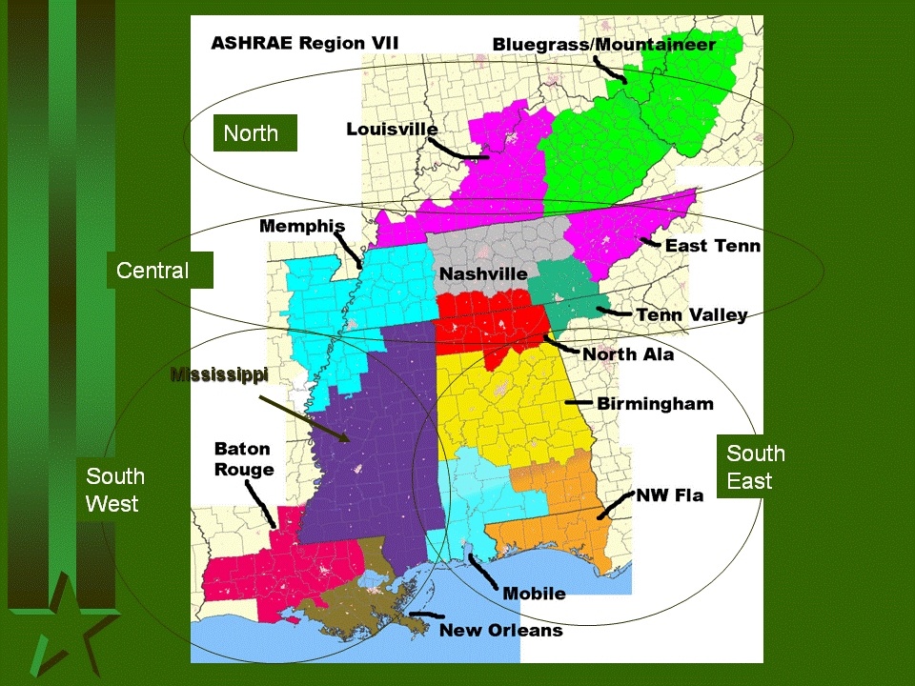

REGION VII
CHAPTER No. | CHAPTER NAME | 2009 MEMBERS
5 | Louisville | 178
56 | Memphis | 210
57 | Birmingham | 261
58 | Mobile | 70
59 | New Orleans | 114
60 | Baton Rouge | 100
61 | Mississippi | 98
88 | Nashville | 300
99 | East Tennessee | 182
114 | Tennessee Valley | 77
128 | Bluegrass | 162
130 | Northwest Florida | 81
133 | North Alabama | 53
Total Members |  | 1886

Region VII had six Society Presidents selected from the region.

Mr. Stan Gilman ……. 1971-72
Mr. Dave Butler ……. 1989- 90
Mr. Billy Manning ……1994-95
Mr. George Jackins….1998-99
Mr. Don Colliver ……..2002-03
Mr. Terry Townsend…2006-07

REGION VII DRC's
BURT LOMAX - JACKSON, MS 1961-66
FRANK VAUGHN - BIRMINGHAM, AL 1966-69
# DON NICHOLS - NASHVILLE, TN 1969-72
BOB KILKER- KANSAS CITY, MO 1972-75*
DAVE LEVINE - NEW ORLEANS, LA 1975-78
BOB LOGSDON - LOUISVILLE, KY 1978-81
DAVID BUTLER- JACKSON, MS 1981-84
RAY THORNTON - LOUISVILLE, KY 1984-87
CHUCK KOPTIS - HUNTSVILLE, AL 1987-90
BILLY COPELAND- MEMPHIS, TN 1990-93
STAN HOUSTON - MOBILE, AL 1993-96
ROGER BUCKMASTER - MEMPHIS, TN 1996-99
HAL LUNSFORD - BIRMINGHAM, AL 1999-2001 (RESIGNED -JOB CONFLICT)

TERRY TOWNSEND - CHATANOOGA, TN 2001-2002 (FINISHED TERM)

HAL LUNSFORD - BIRMINGHAM, AL 2002-2005

ART HALLSTROM - LEXINGTON, KY 2005-2008
PAT KEMPF- FORT WALTON BEACH, FL 2008-2011
# Don Nichols was Society Treasurer for two terms but decided not to continue in the “Chairs” to become Society President.
IN 1972, REGION VII INCLUDED KANSAS CITY AND ST. LOUIS.
THIS CHANGED IN THE MID70's.

A HISTORY OF THE BIRMINGHAM ASHRAE CHAPTER

7/6/10

By Wayne Mathews, Chapter Historian and Past-President

Around 1958-59, two organizations serving the heating, ventilation, and refrigeration industry came together to form one national association serving the growing commercial air conditioning market. The American Society of Heating and Ventilation Engineers (referred to back then as ”ASHVE”), and The American Society of Refrigeration Engineers (“ASRE”) became the American Society of Heating, Refrigeration and Air Conditioning Engineers (ASHRAE). The combined national group was seeking to establish chapters in major cities to promote and guide the industry.

Our chapter in Birmingham began as the North Alabama chapter of ASHRAE and was primarily organized by Frank L. Vaughn, P.E., Southeast Regional Manager for Sporlan Valve, and a member of the Birmingham Refrigeration Engineers chapter. Frank understood the value that an association of engineers, contractors, vendors, suppliers, and utilities could bring to our companies and local business. In his travels around the southeast, Frank was instrumental in forming ASHRAE chapters in Nashville, Knoxville, Mobile, Montgomery, and his home base of Birmingham.

For the combined ASHVE and ASRE Birmingham chapter Frank wanted a dynamic leader to serve as the first chapter president. He recruited Eddie Miller (later of Miller and Weaver, Consulting Engineers) who was in-house mechanical engineer for Van Keuren Davis and Associates, AIA. Frank Vaughan served as the first chapter treasurer. Also in 1958, a young George Jackins graduated from Georgia Tech, who had joined ASHRAE as a student member, moved to Birmingham as a sales engineer for the American Blower Co.

Frank and Eddie gathered a list of names of everyone that they thought would be interested in forming a local chapter to meet regularly to discuss technical issues, have dinner, and socialize. Frank paid for the postage himself and mailed dozens of flyers announcing the formation of the new ASHRAE group. Frank realized his work was cut out for him in getting this new group formed when he didn’t receive back a single reply.

Undeterred, they slowly built attendance at the monthly dinner meetings, held mostly at steak houses such as the old Golden Nugget in Homewood. The membership grew steadily to over 175 by 1974 when George Jackins became chapter president. The dinner meetings shifted from restaurants to clubs and over the years were held at The Club, Altadena Country Club, and Green Valley (Hoover) Country Club.

View Region VII website for “the rest of the story”~
Chapter Histories: ASHRAE Region VII

